

**ISIT307 BACKEND WEB PROGRAMMING**

**Assignment 1**

My name: Leviandran, Dominic Loh

My SIM student number: 7222348, 10227916

My email address: [leviandr001@mymail.sim.edu.sg](mailto:leviandr001@mymail.sim.edu.sg), [djkloh002@mymail.sim.edu.sg](mailto:djkloh002@mymail.sim.edu.sg)

Assignment number: 1

**Table of Contents**

**User manual…………………………………………………………………………………………………**

**Test data……………………………………………………………………………………………………..**

# User Manual

## Homepage

In the HomePage, the User can choose to List a Gear, View the listed Gears or search for specific listed Gears by typing in the product ID. There is also a navigation bar on all the pages below the page header for easy navigation for all of the pages.

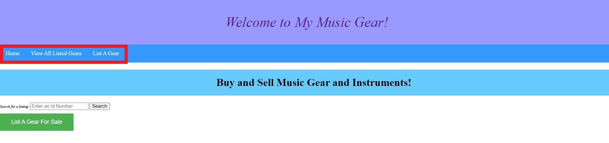

## List A Gear

The User can enter his/her contact details (name, phone number and email) and Information about the Music gear (ID number, brand, year of manufacture, condition) that the user wants to list.

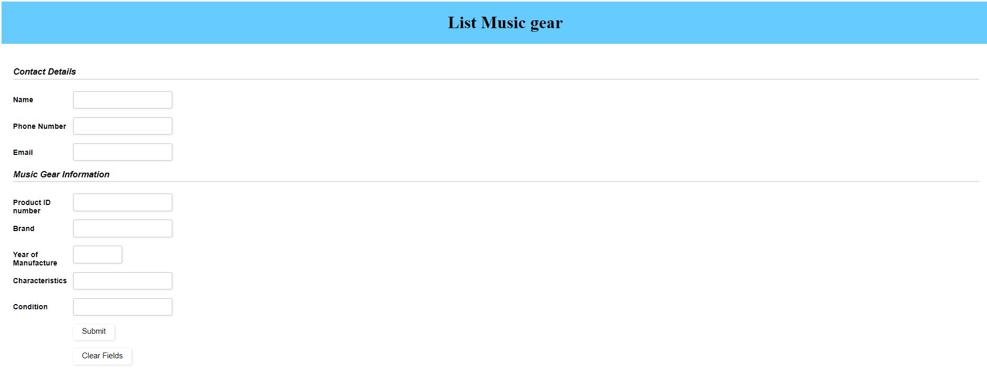

## View All Listed Gear

User can view the information of all the listed gears in the “view all listed gears” page from the navigation tab, there is also a back to top function button to return the user to the top of the site

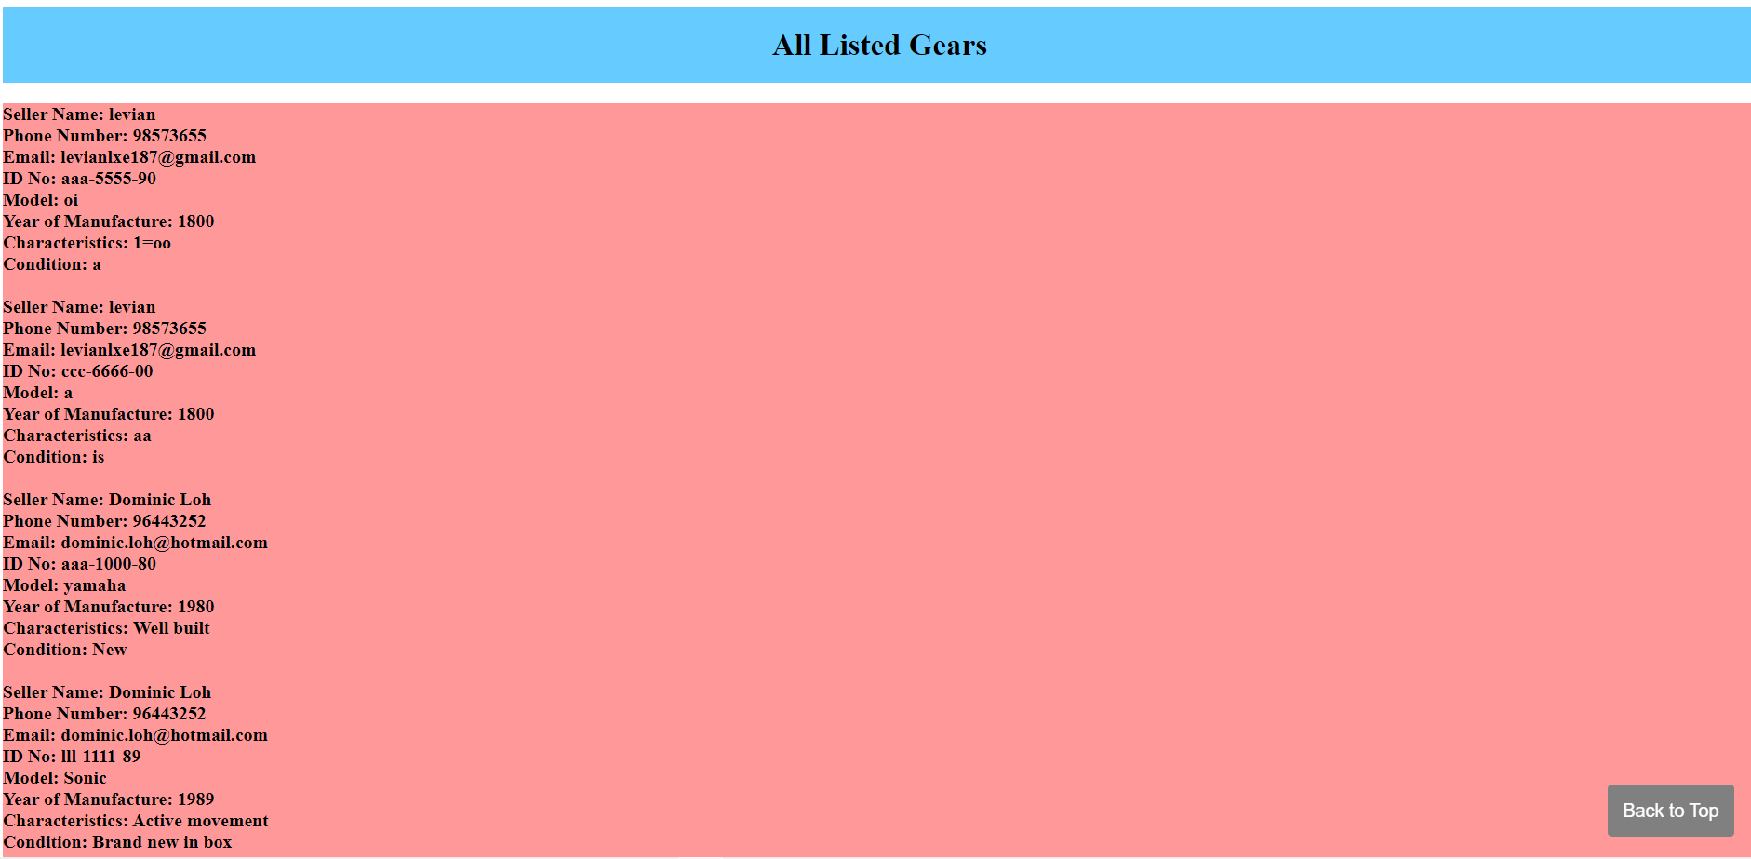

User may also use the search function on the Homepage to find specific listings of music gears through the unique id number identifier from the search field

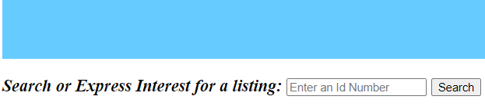

## Search Result and Express Interest

After clicking on the search button, the user will be brought to the search result and express interest page where based on their input will be shown different values. The user can also express interest for listed gears if they have the associated product id.

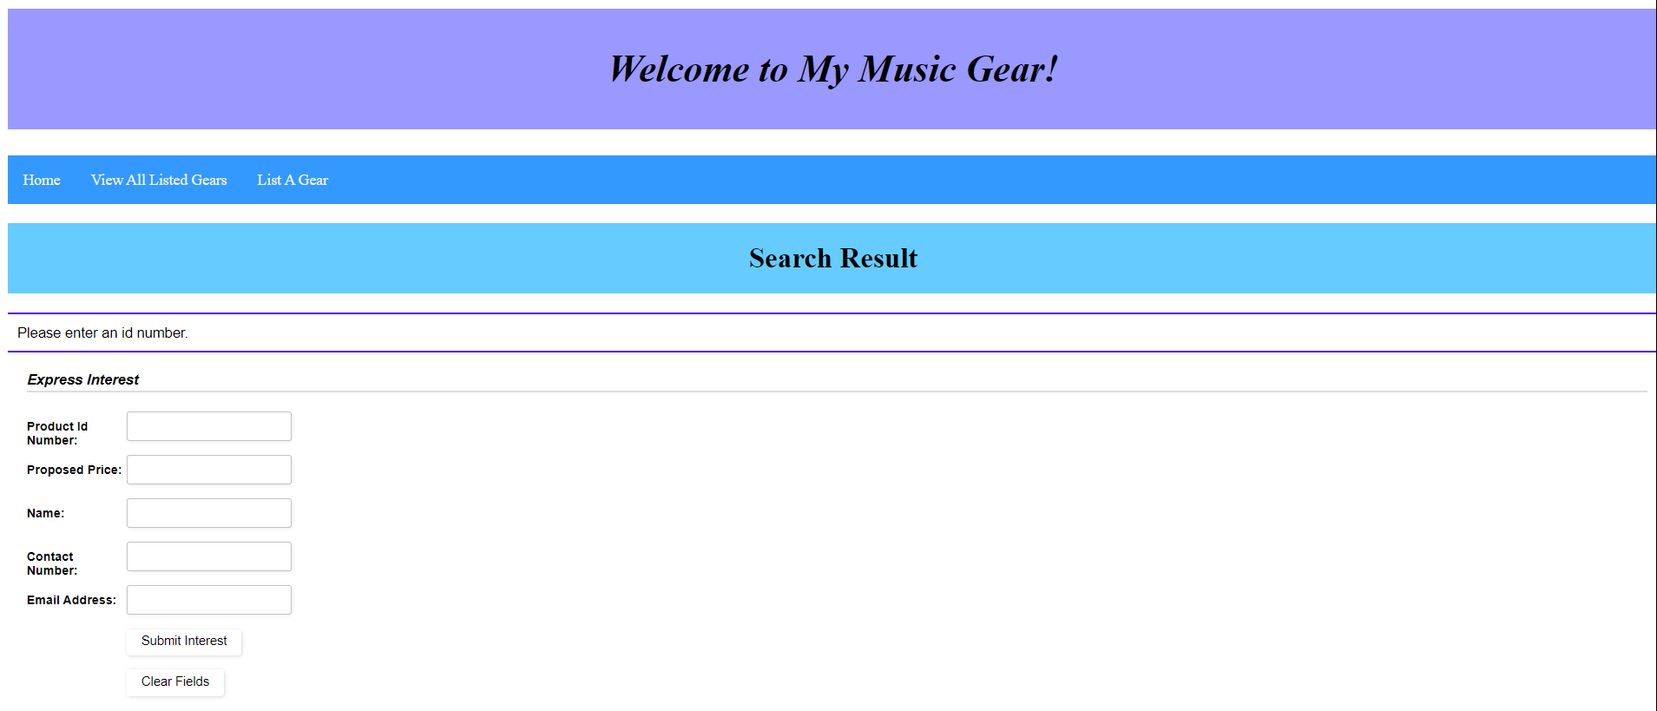

# Test Data

Validation is in place if the user attempts to submit an empty form

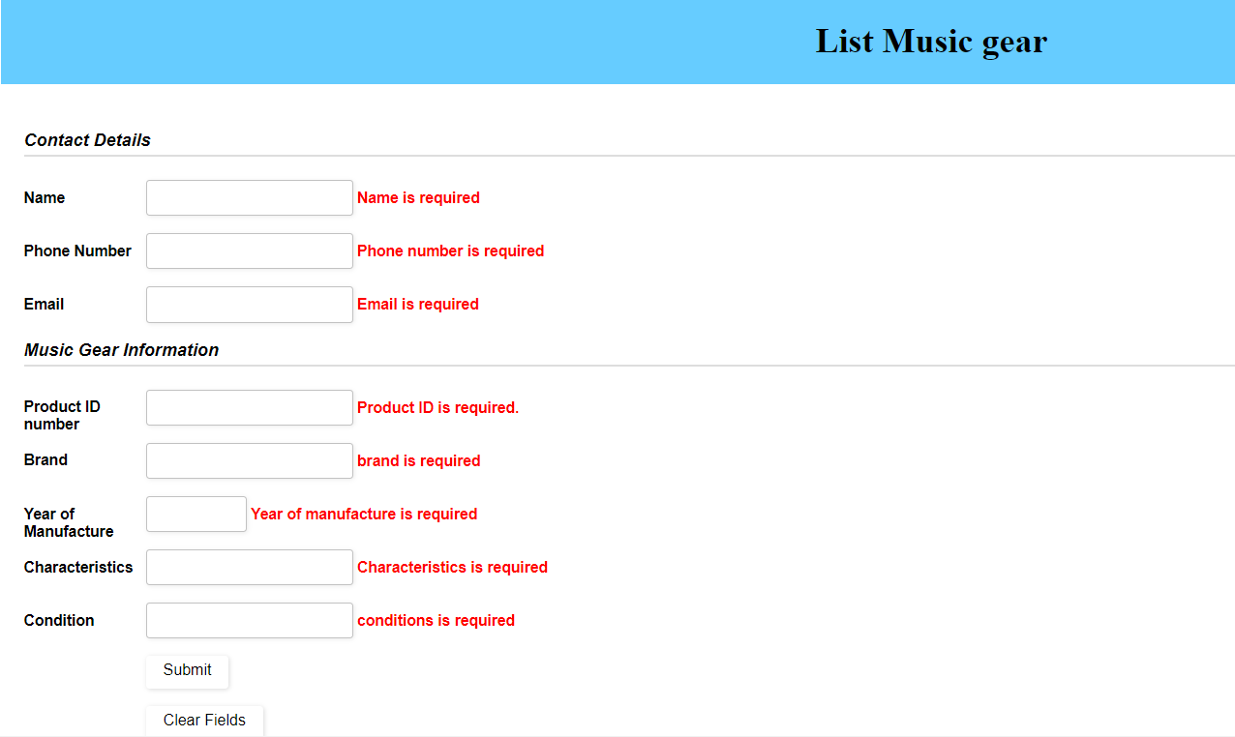

Error message will pop up if the user attempts to submit a product ID that has already been listed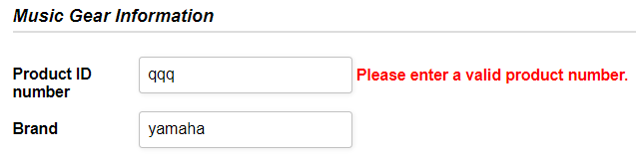

Input of Phone number and Email address have been validated when submitting the form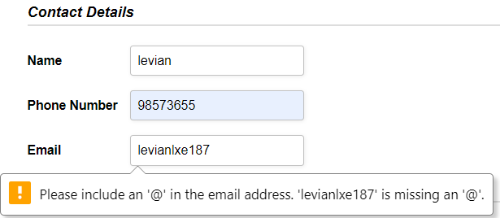



Product ID number has been validated to the format of ‘ccc-nnnn-yy’



For the search function there are 3 possible outcomes when clicking on the search button based on the input in the search field.

The first outcome is that there is no input in the search field, this will return an error message of “Please enter an id number”

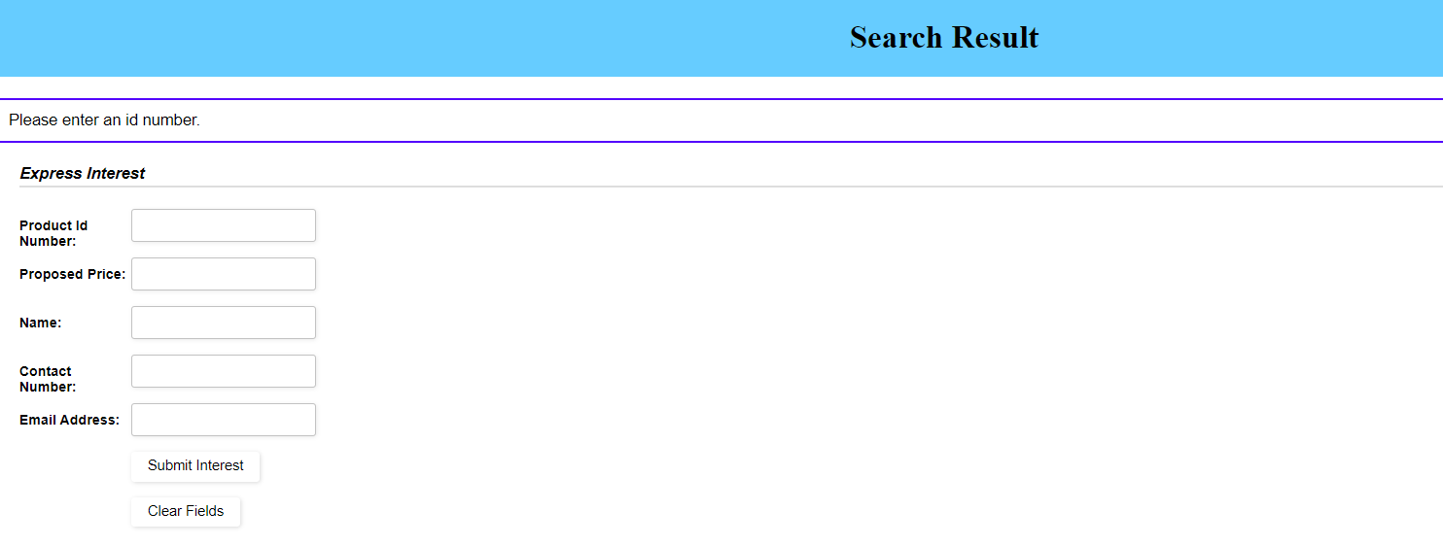

The second outcome is that an invalid id number is entered, this will return an error message of “Id number not found”

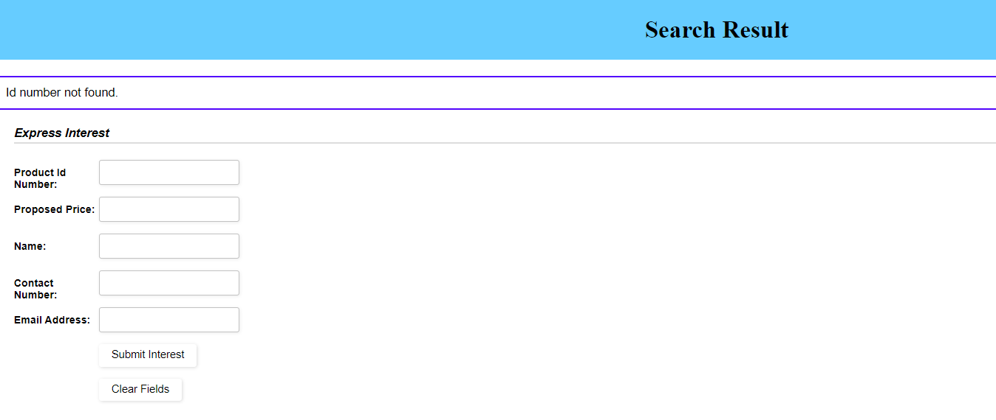

The third outcome is that a valid id number is entered and the full listing details are shown to the user.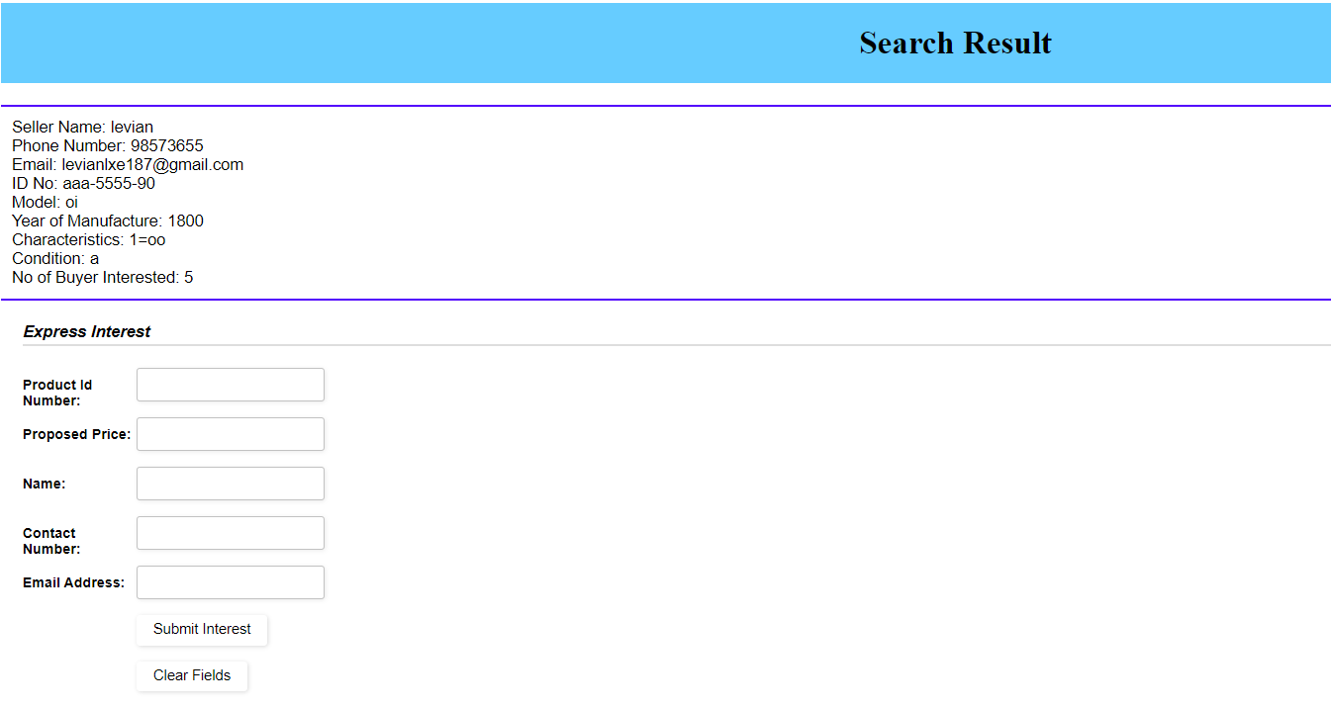

User can enter their contact information to express interest for the music gear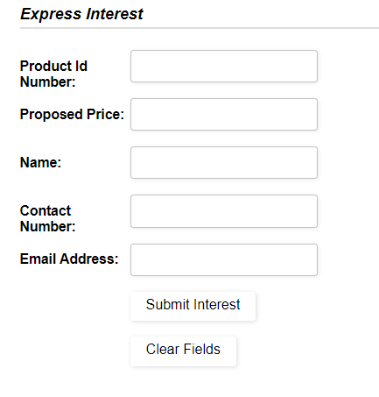

The same validation applies for the Product Id Number, Proposed Price, Name, Contact Number and Email Address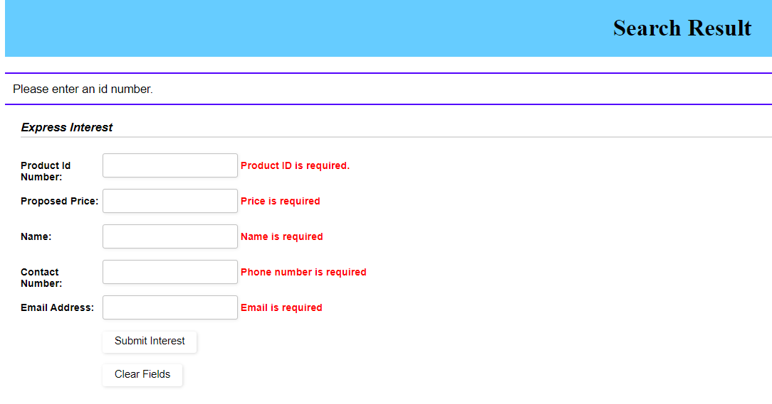

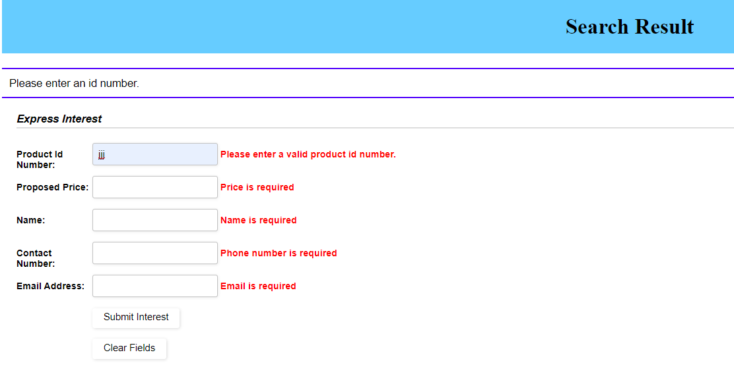

Once the user submits the express interest form, the system will update the number of interested buyers